EECS 351

Introduction to Computer Graphics

Project C

Better Lights & Materials

Instructor: Prof. John Timblin

Name: Ang Shen

NETID: asi031

03/10/2015

**Introduction**

In this project, a snow scene is drawn using WebGL and HTML-5 on a browser. Based on project A and B, snowman and a tree are drawn on the Canvas with animation. In this project, more realistic interactive lighting and materials are created using WebGL.

**User Guide**

Part I Without Control

The browser shows a snowman whose body and head turns around automatically with a constant speed. In addition, a tree is drawn on the Canvas as well. The tree rotates along z-axis over time. The size and the shape of the tree is changed over time as well. A snow background is loaded behind it. At the left side of the browser, build-in buttons and instructions for HELP manual will be shown as well.

Part II User Control

* On the left bottom of the screen, **<<Spin** and **Spin>>** will increase or decrease the spinning speed of the tree. Same functionality can be achieved by pressing **‘+’** and **‘-’** on the keyboard.
* **Tree View** and **Origin View** buttons are used to change the projection view between user and the top of the tree.
* Click **Run/Stop** is used to pause the snowman.
* Press **‘H’** key on the keyboard to get the brief user control manual.
* Press **Up, Down, Left, Right** to control look at point.
* Press **W** and **S** to move camera forward and backward.
* Press **A** and **D** to move camera left and right.
* Press **Q** and **E** to move camera up and down.
* Drag mouse to move the snowman.
* Press **1** or **2** to increase or decrease ambient
* Press **3** or **4** to increase or decrease diffusion
* Press **5** or **6** to increase or decrease specular
* On-browser button **Light0 on/off** and **Light1 on/off** can switch the two light sources on and off respectively. Same thing for **Ambient0 on/off**, **Diffuse0 on/off**, **Specular0 on/off** and so on.
* On-browser button **Light1_X_Add** and **Light1_X_Sub** can move light1 along axis. Same thing for **Light1_Y_Add, Light1_Y_ Sub, Light1_Z_Add, Light1_Z_Sub.**

**Scene Graph**

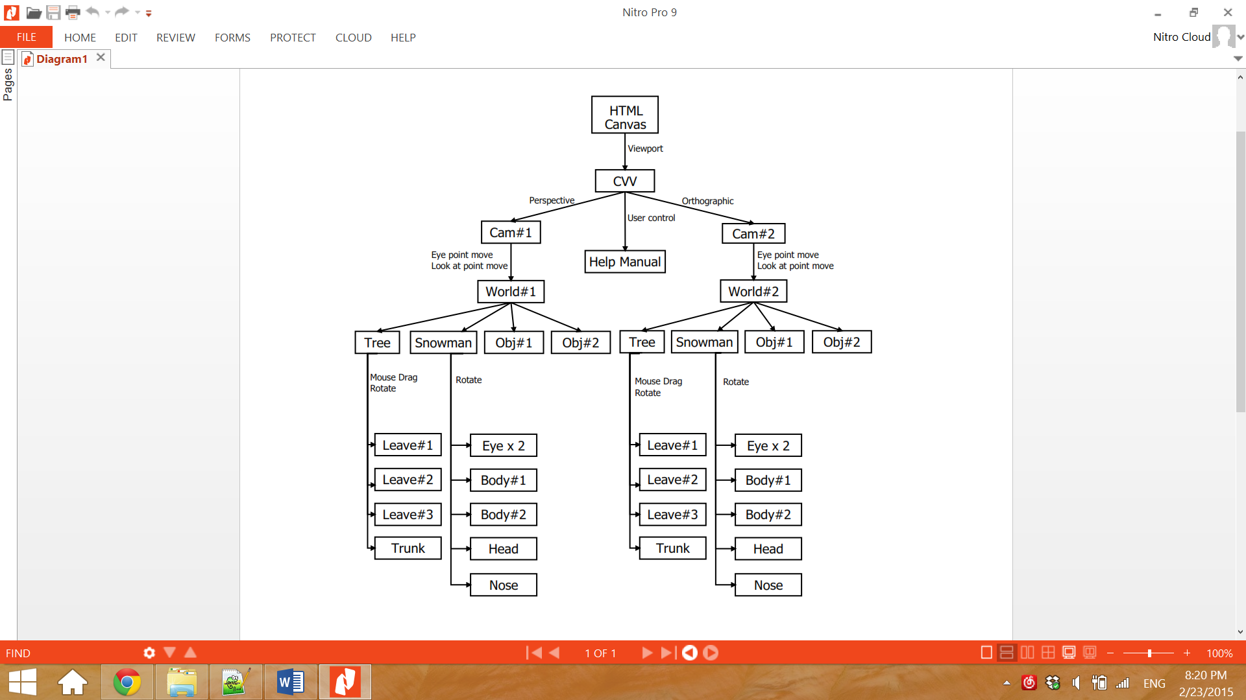

**Results**

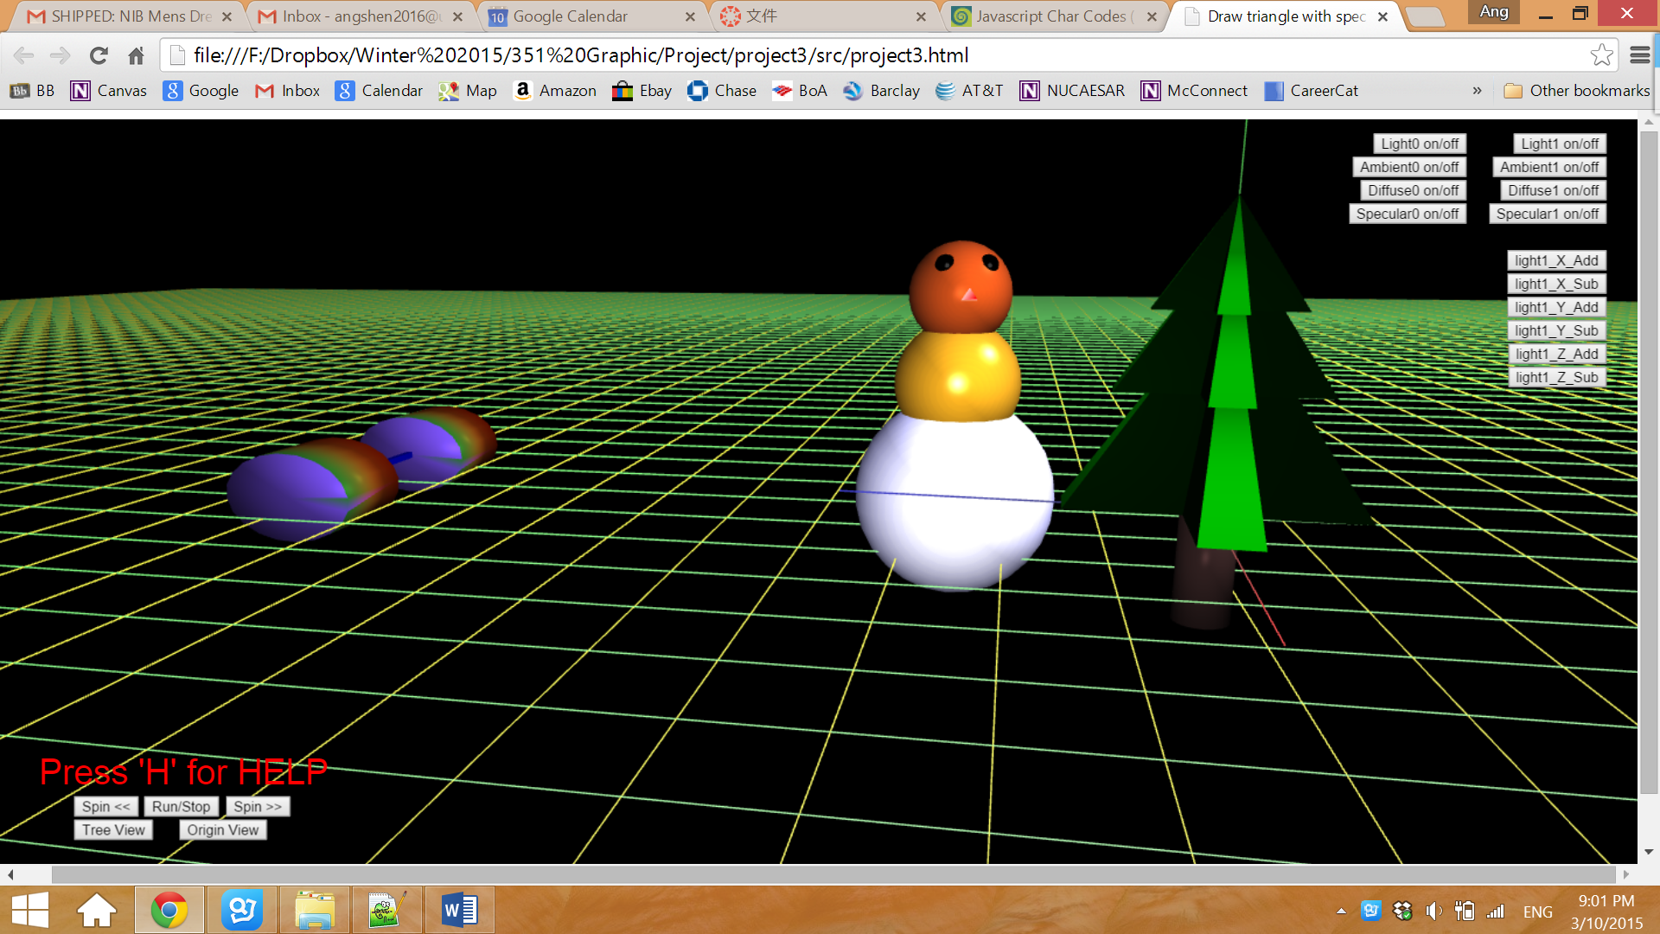

Figure 1. Initial Page

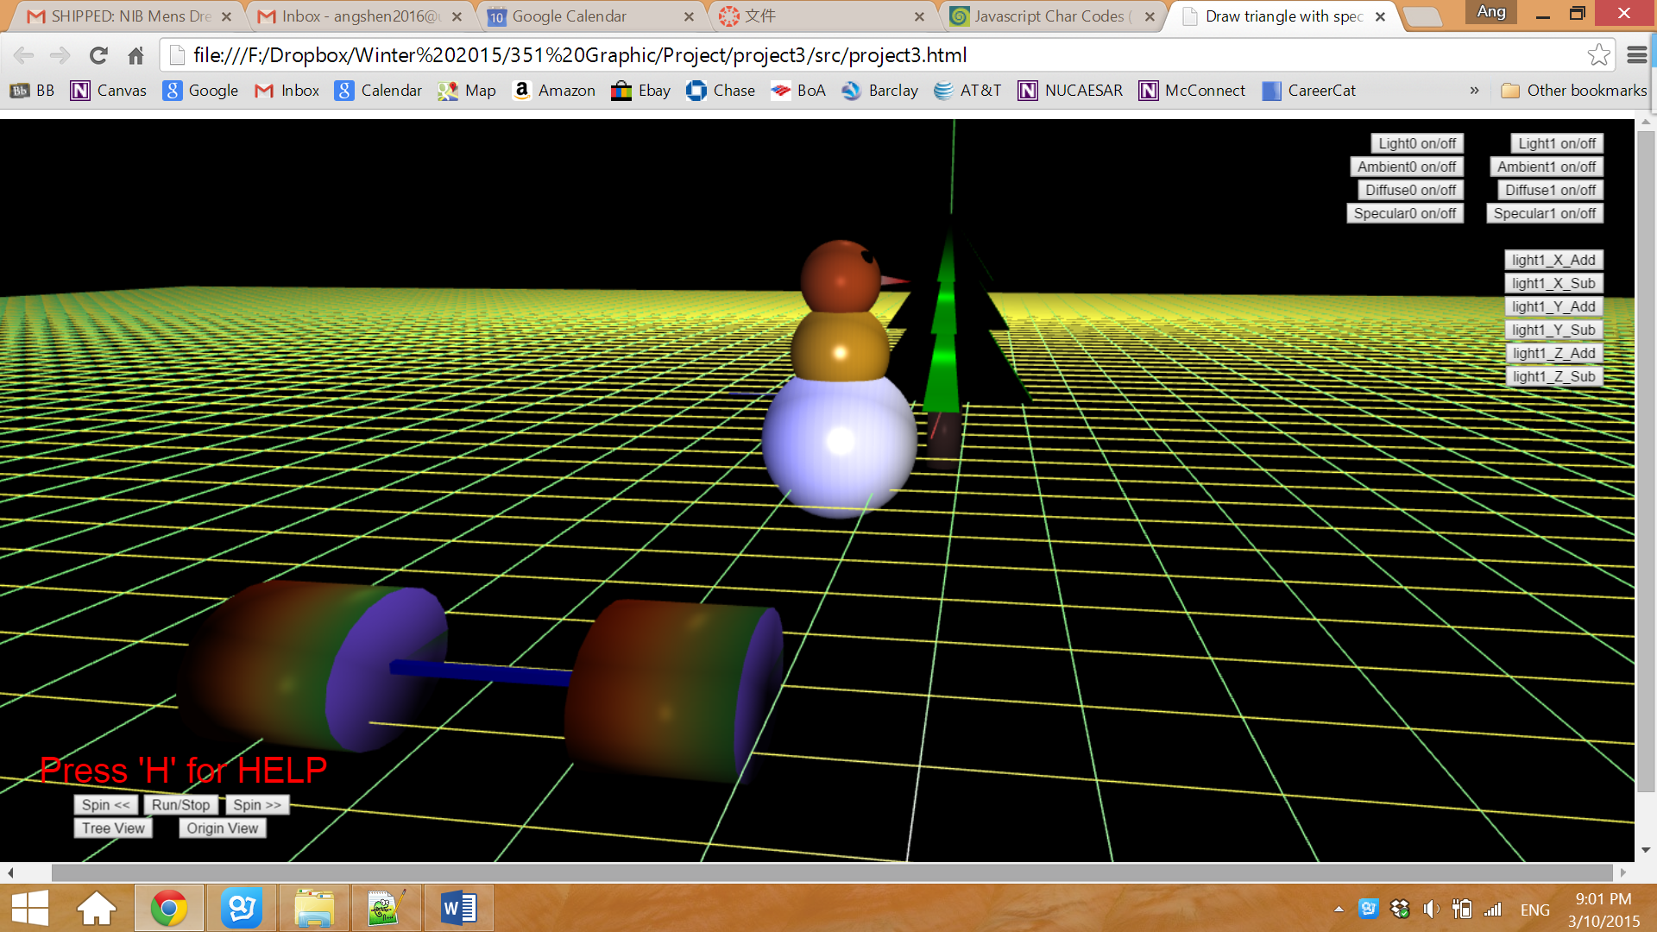

Figure 2. Scene after moving camera

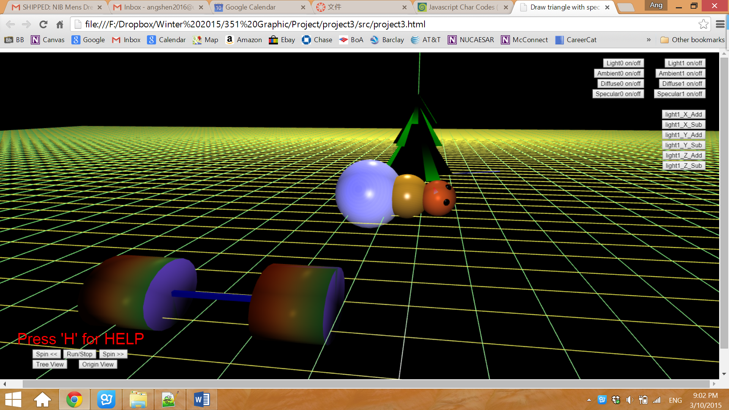

Figure3. Snowman after moved by dragging mouse

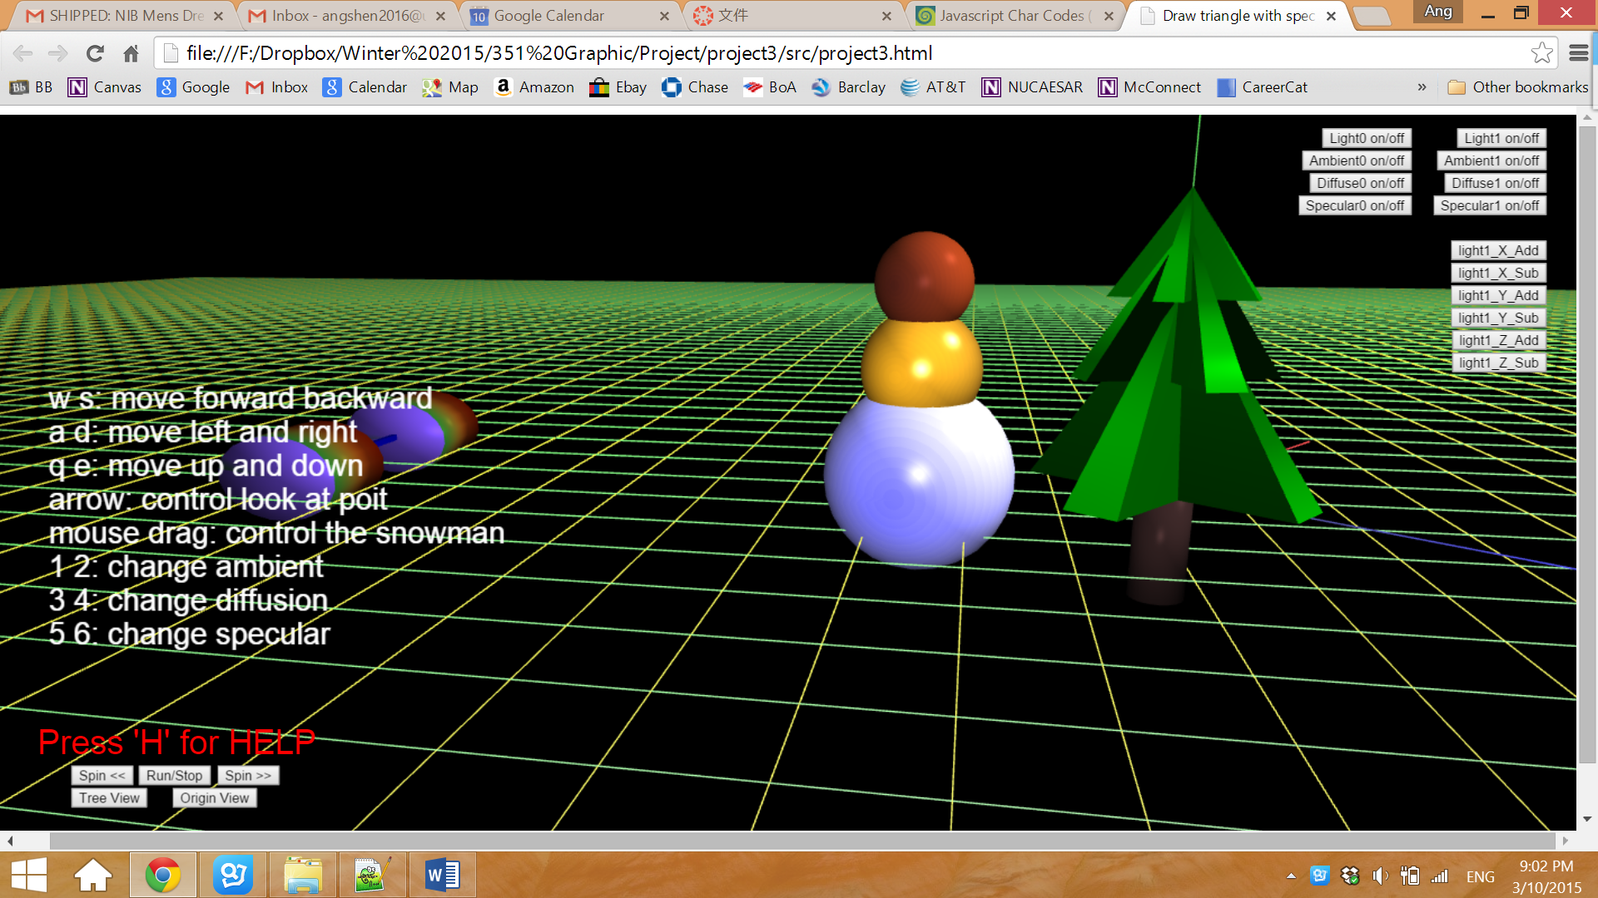

Figure 4. User guide popped up when **‘H’** is pressed

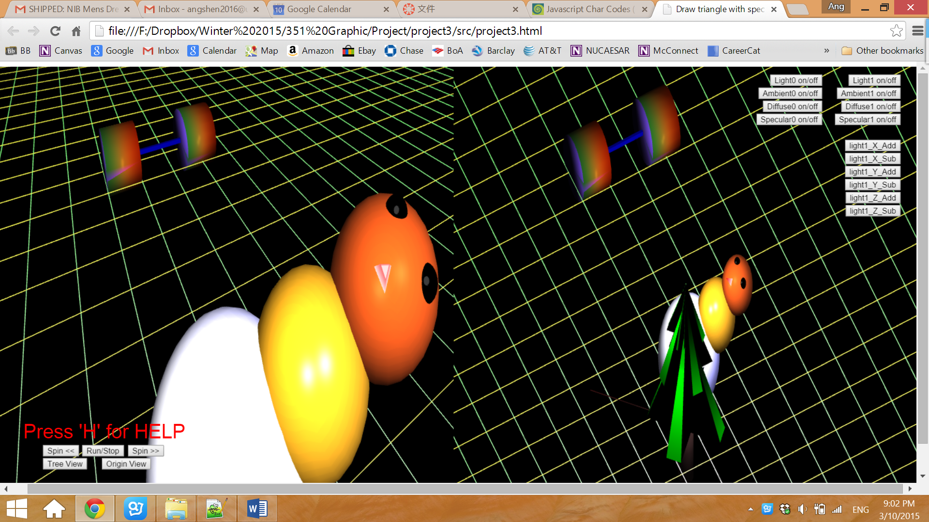

Figure 5. Projection view of the top of the tree

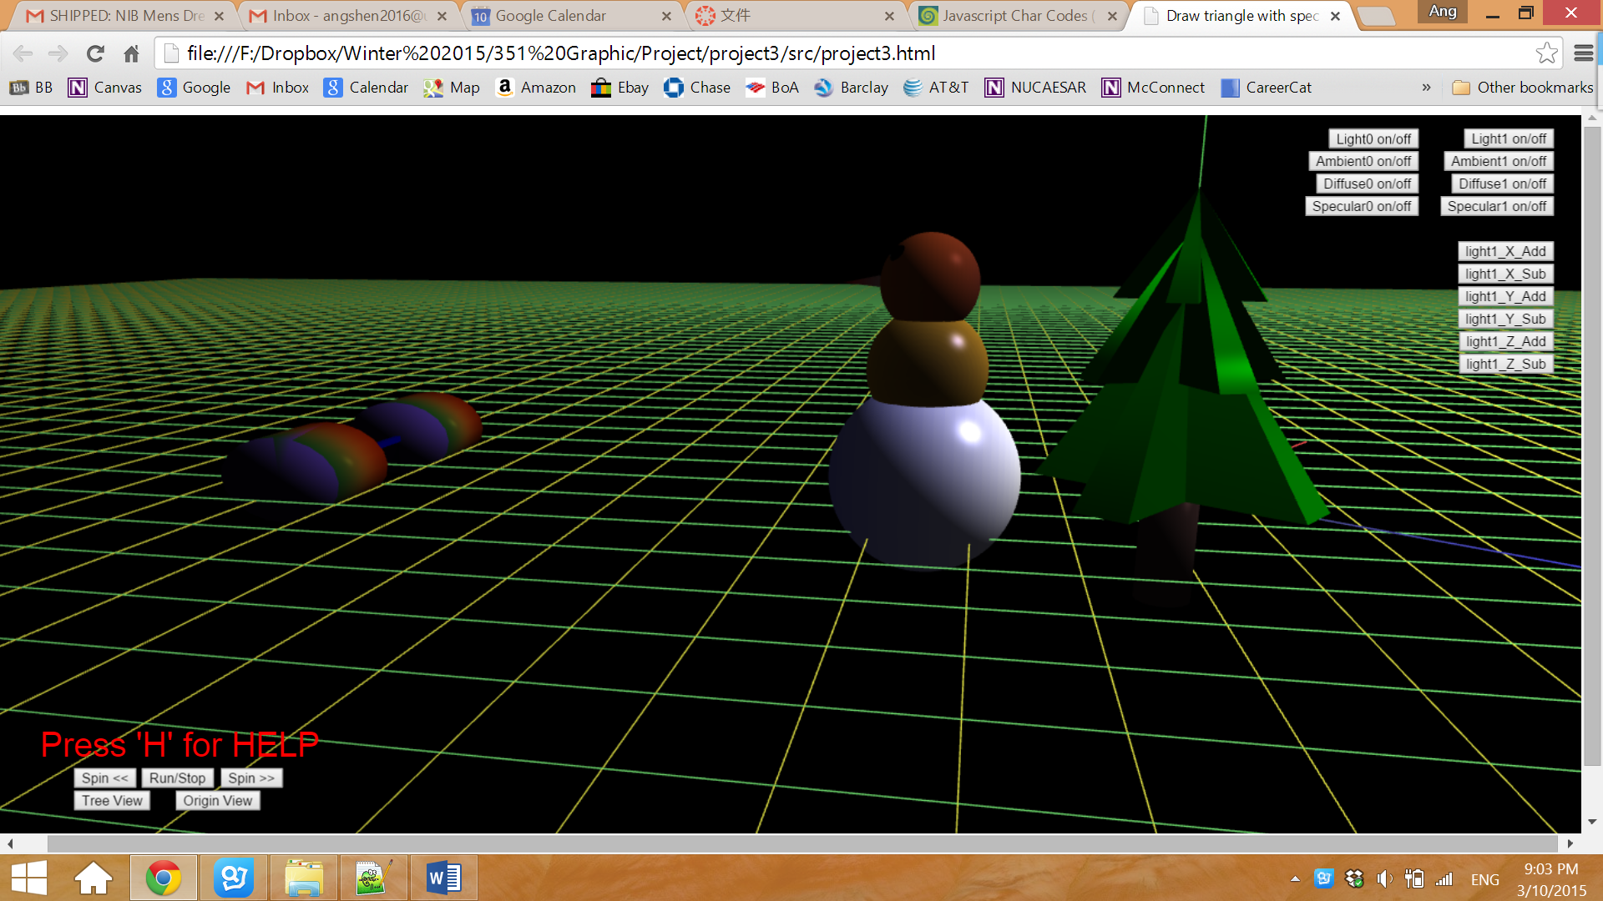

Figure 6. Light0 is turned off

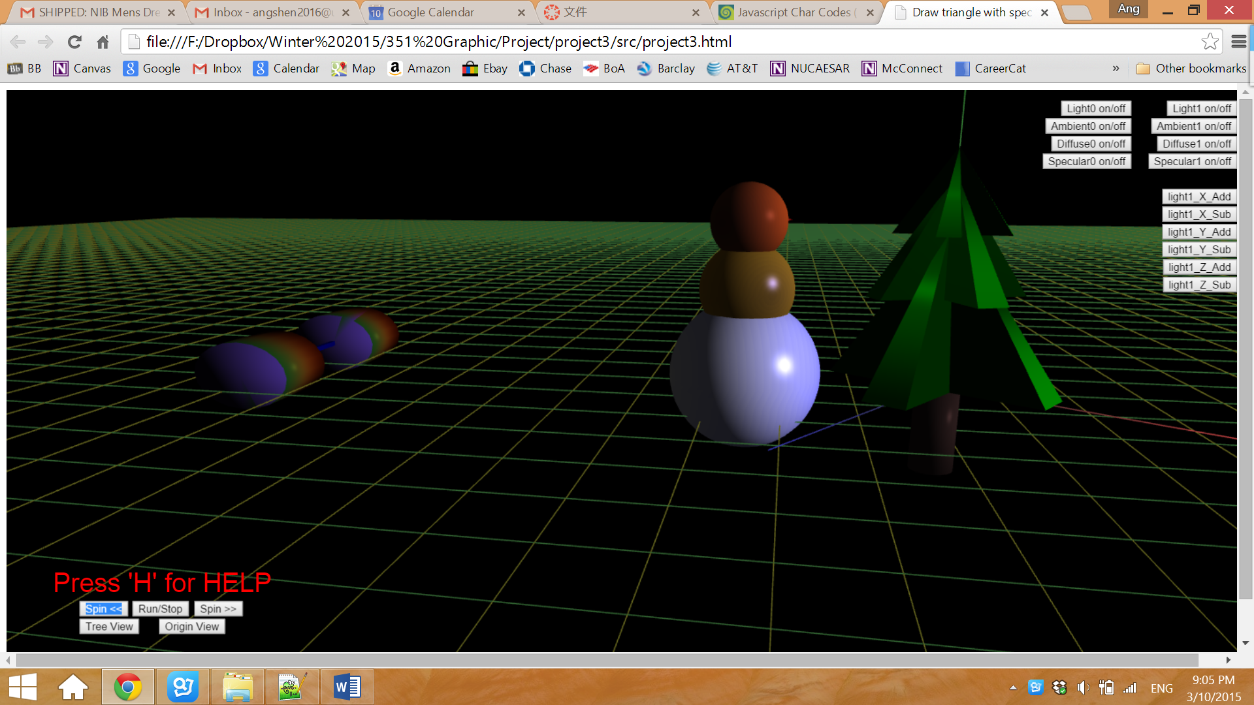

Figure 7. Modify location of light1 when light0 is turned off

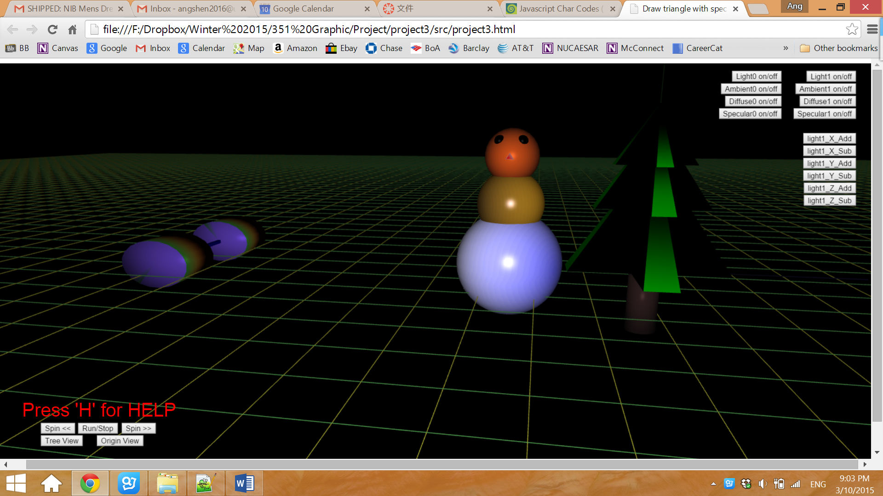

Figure 8. Light1 is turned off

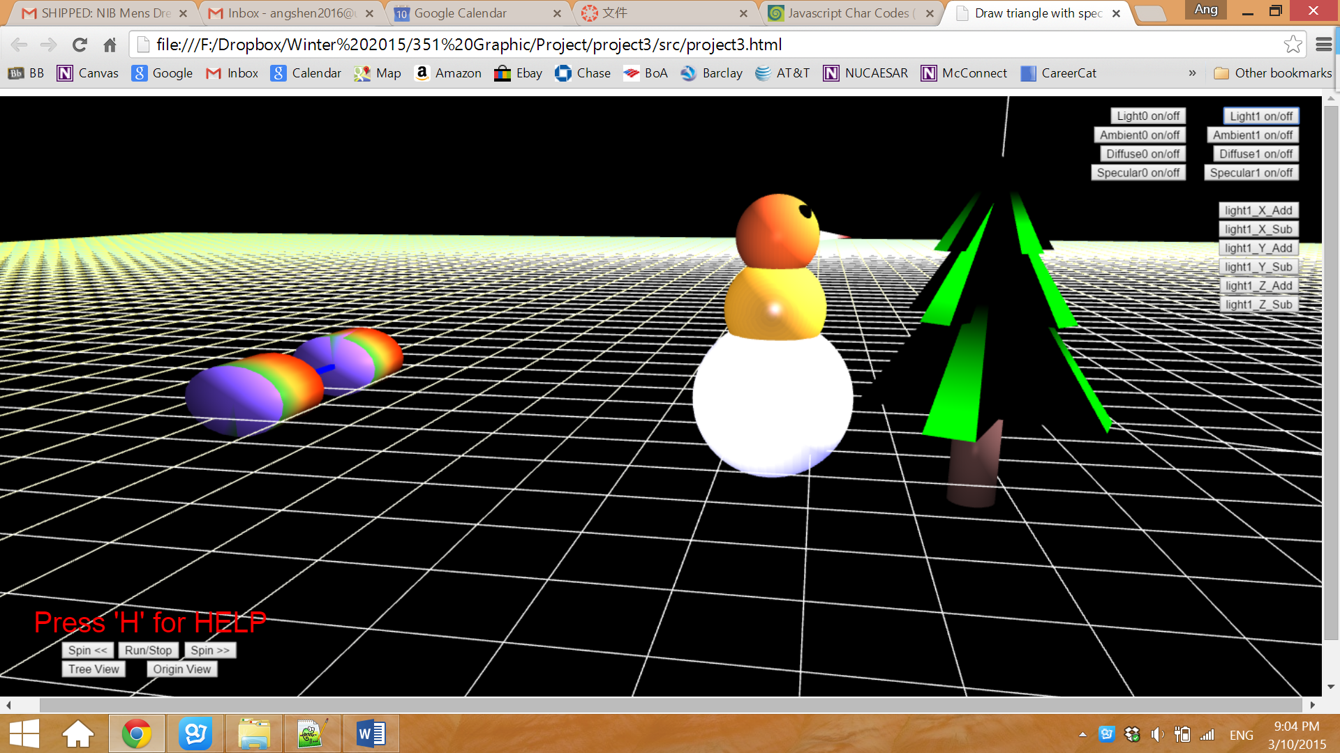

Figure 9. Modify ambient, diffusion and specular of light1 when light0 is turned off